**Lab1**

**Name: Kokil Dhakal**

**Section One-Absolute Fundamentals**

1.

2.

3.

4.

**After update:**

5.

**After Deletion:**

6.

**After dropping table:**

As the error message says “Cars” table does not exist. Which means there is no such “Cars” table in the current database. As we know we just dropped the table from the database and that is what we are expecting.

**Section Two:**

**7.**

8.

**After inserting rows:**

**9. Invalid insertion:**

a. Null value is absence of value. That means there is Apartment Name missing for Apartment number 252 in this Apartments table. In SQL missing value is represented by Null which does not means it is zero or empty string.

b. NOT NULL constraint is a rule imposed to the table in which given attribute cannot have null value (missing value). For example, we made a rule for table “Apartments” that apartment name cannot be missing in the table.

c.

As we made a rule that apartmentname should always have not null value and when we tried to insert the null value, it triggers that rule and gives the error message. Saying violation of not-null constraint. And it also locates which row has those null value insertion conflict.

**10. Valid insertion:**

11.

As ‘SELECT’ command select everything from the table but if we are looking for specific column and/or specific row it is very easy and convenient to get those values to review. This filtering method is very useful to check the specific value or range of value of our interest out of a large numbers of rows and columns.

12.

After update:

13.

After Update:

14.

After rows deletion:

15.

a.

I made Employee table with four columns as follow.

b.

Data anomalies may occur due to data redundancy. For example, there is Let’s say Rick from Network used to work in department D001 moved to new department D002. If we want to retrieve Rick’s info, we might not get right information about the Rick because there is duplication of entry for Rick, and we don’t know exact department he is working. And this is because of our database lacks data integrity; it has more than one value for same employee. This is insert anomalies.

c. to explain deletion anomaly I am adding one more employee information to the Employee table. And table looks like this now.

Now, let’s say Christine leaves the company and company deletes Christine info. Deletion anomaly may occur when they delete Christine info also mistakenly delete the Jean’s information. As they worked in the same department.

All these anomalies may occur because there is data lack of data integrity as there are more than one entry for same employee and lack of data normalization.

Similarly, update anomaly may occur when updating specific row/s also update another row/s which we don’t want to update. This can affect whole process of getting correct information about the data.

16.

For database table I will be using table below:

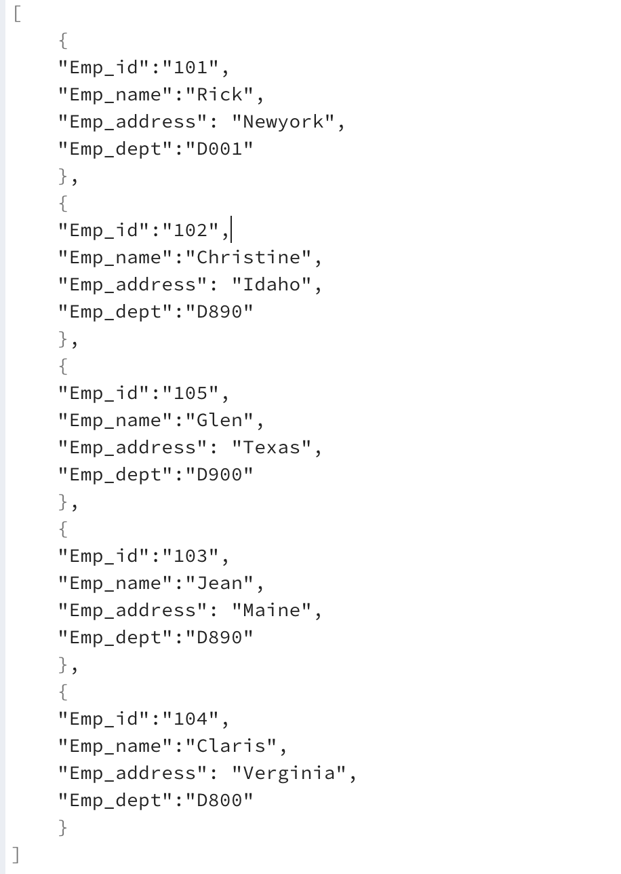

I will be using JSON file for this exercise. JSON is a great data format because it is simple, lightweight, and ideal for passing around raw data in a very basic format with a syntax suited to storing and exchanging data.

1. **Efficiency:** Database tables can be indexed, which allows for faster searching and retrieval of specific data. While searching through a large file can be time consuming. Database management systems are designed to handle concurrent access to data and hence efficient whereas it not possible to handle concurrent access in file they are usually locked while it is being modified. DBMSs have built in mechanism for backup and recovery, which can be more efficient than manual backups of individual files.
2. **Security:** Database tables are more secure as compared to file in many ways. DBMSs provide mechanisms for controlling access to data such as user authentication and authorization. This allows for fine-grained control over who and what can access and modify data in the database. While files are usually accessible to anyone with access to the file system. Also, Many DBMSs support encryption of data at rest and in transit which help protect sensitive data from unauthorized access. Encryption of the file can be done but it is not seamless as in database. In other hand files can be stored on a separate, isolated file system that is not directly accessible from the network. This can help protect the files from unauthorized access.
3. **Structural Independence:** Application use to access table data does not rely on file location while application use to access file data does require full location of the file for example C:\Employee.json. If location of the file is moved, application might not work. Structural independence is a particular attribute of a database that can allow users to make changes within the structure of the table like adding columns or deleting columns etc. without having adverse effect on the application program’s ability to access data within the table. While changes in file structure have adverse effect on application to access file data.

**Resources:**

1.Book: Database Systems design, and implementation and management-chapter 1 and 2

2. Module 1 online martials.